Contents

Chapter 3 Client Acceptance of Beta Release and Proposed Final Release 2

3.1 Chapter Summary 2

3.2 Client Communication via Email: 2

3.3 Client Signed Acceptance of Beta, Feedback and Proposed Final release 2

3.4 Proposed Final Release 2

## Chapter 3 Client Acceptance of Beta Release and Proposed Final Release

### 3.1 Chapter Summary

This chapter presents the communication maintained throughout the Beta phase, Client’s acceptance and feedback of the delivered Beta release and the proposed Final release based on the feedback received.

### 3.2 Client Communication via Email:

We were in constantly communicating with the client via email and also some personal meeting was done where we felt that email was not helping us to maintain the iteration as it is necessary for the projects following Agile development model. The main forms of communication include mail, Client meeting and phone call for quicker response.

### 3.3 Client Signed Acceptance of Beta, Feedback and Proposed Final release

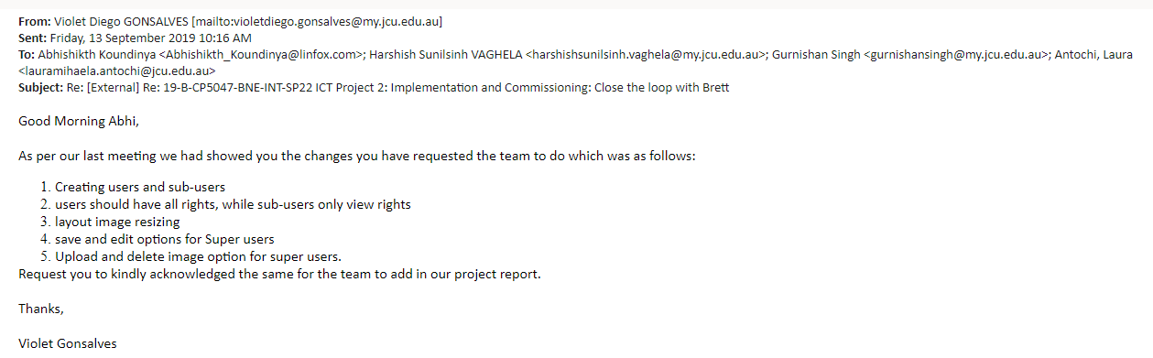

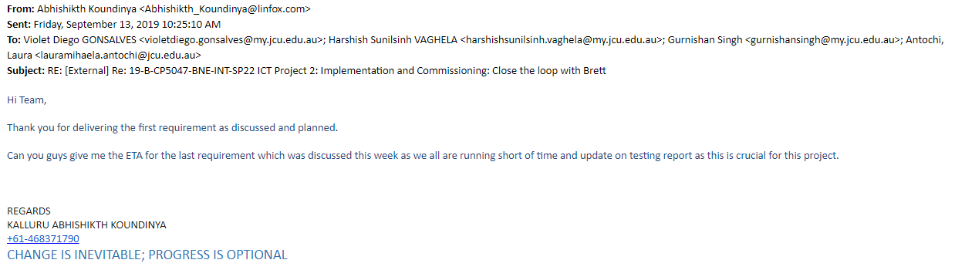

### 3.4 Proposed Final Release

Below are the user stories for the final release:

|  |  |  |  |  |  |
| --- | --- | --- | --- | --- | --- |
| **Sr.No** | **User Story** | **Description** | **Priority** | **No. of days** | **Status** |
| 1 | Robot Layout | As a user I want to see the robot layout of my pallet | **10** | 4 |  |
| 2 | Create database table | As a user I want to see tables in the database | **10** | 2 |  |
| 3 | Upload Image | As a user I want to upload images with super user access | **10** | 1 |  |
| 4 | Delete Image | As a user I want the access to delete images from components and sub-components | **10** | 1 |  |
| 5 | Save Link/Edit Link | As a super user I want to save or edit button on the components and sub-components option | **10** | 1 |  |
| 6 | Navigation Bar (Update) | As a user I want to use the navigation bar and update the nav bar | **10** | 1 |  |
| 7 | Image Mapping | As a user I want to map image with various components | **10** | 1 |  |
| 8 | Select.php | As a user I want to fetch the data from the select. Php page | **10** | 1 |  |
| 9 | Select component | As a super user I should be able to view and select the various components and subcomponents | **10** | 1 |  |
| 10 | Login page | As a user I want to have a new login page with change in background image and change in tabs | **20** | 1 |  |
| 10 | Upload Sub_Image(Function) | As a super user I should be able to upload images to various sub-components | **10** | 1 |  |
| 11 | Delete sub_Image(Function) | As a super user I should be able to delete images from various subcomponents | **10** | 1 |  |
| 12 | Image enhancement | As a super user I want have the adjust the image to see the results more suitably | **10** | 2 |  |
| 13 | Manual (Update) | As a super user I want to update the manual so that any layman can understand the code if there is a new joinee | **50** | 3 |  |
| 14 | Testing |  | **20** | 7 |  |

## Chapter 4 Project Development and Release ICT Infrastructure

## 4.1 Chapter summary

In this chapter, project development and ICT infrastructure release environment are discussed. Project collaboration tool, test environment and tools used to make this project successful.

## 4.2 Development Tools and Environment

Project development environment was set on laptop for each team member so that they can work and test their work done. We used project collaboration tools to update on the status of the project completion work by each member. We mostly worked on Xampp server which is a local environment as our localhost server.

### PhpStorm:

Php storm is a commercial cross platform test environment build on jet brains platform. It provides an editor for [PHP](https://en.wikipedia.org/wiki/PHP), [HTML](https://en.wikipedia.org/wiki/HTML) and [JavaScript](https://en.wikipedia.org/wiki/JavaScript) with on-the-fly code analysis, error prevention and automated [refactorings](https://en.wikipedia.org/wiki/Refactoring" \o "Refactoring) for PHP and JavaScript code. PhpStorm is built on IntelliJ IDEA, which is written in [Java](https://en.wikipedia.org/wiki/Java_(programming_language)). Users can extend the IDE by installing plugins created for the IntelliJ Platform or write their own plugins.

#### IDE

Photoshop:

We used Photoshop to enhance the visual quality and size of the Layout image obtained from the client. This image is used to determine the coordinates of each hotspot in the layout.

GIT HUB

As this is a team project, we need to regularly update all team members as the project progresses. Version control provides a clear view of project development by ensuring that the project's current iteration is known. GitHub is an open source version control system (VCS). Git is the core of GitHub's web and desktop versions. You can create, edit, and update repositories in both the web and desktop versions. This can be shared and verified by all team members.

While working on the beta release, our choice for version control was git for managing different versions of the project. In the process of this alpha release, we were able to properly use the git platform while using git platform, allowing the team to work on different aspects of the project individually.

### XAMPP

Xampp is free open source software which is used to install Apache distribution with MariaDB, PHP and Perl.

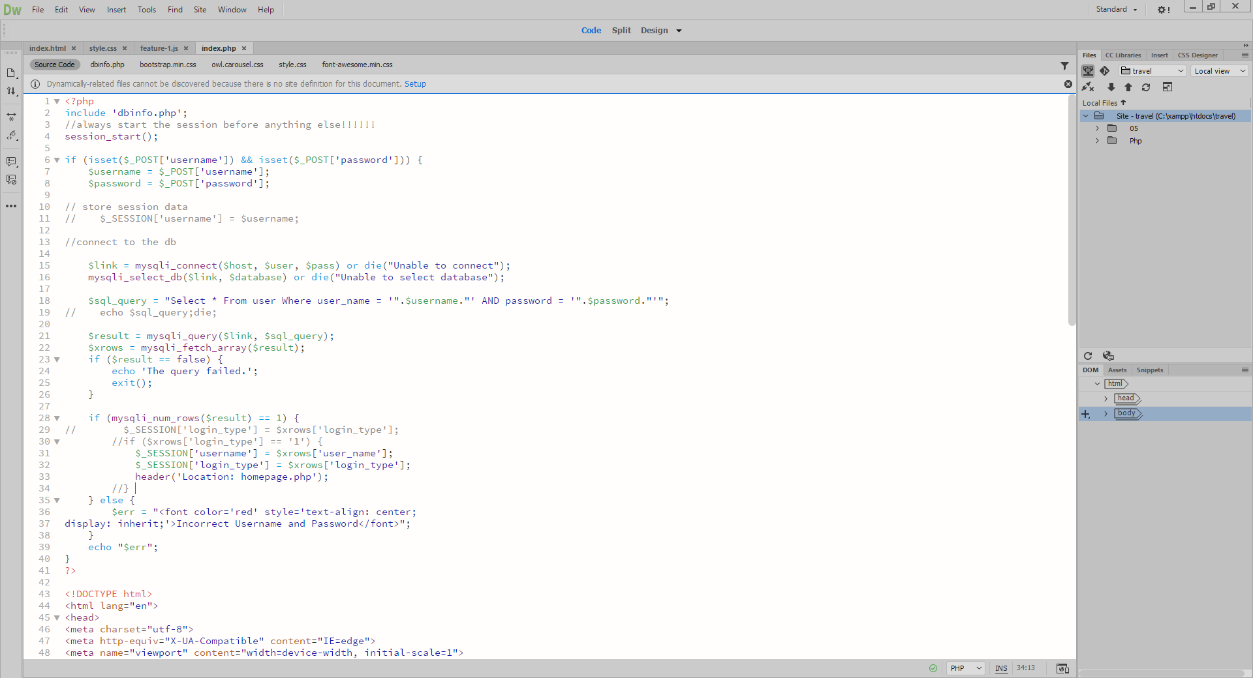

## 4.3 LANGUAGES

HTML & CSS

Hypertext Markup Language and Cascading Style Sheets. In order to achieve the desired page design, we used html and CSS, html to create the page and design structure most suitable for me, and added the style and personality to the web page using CSS.

JavaScript:

We used JavaScript for validation and visual effects, to make the page and popup more interactive and dynamic with beta release, we created a hamburger menu, image resize, pop-up with the help of JavaScript.

Jquery

In the alpha release process, we used jQuery. This is a back-end implemented JavaScript library that helps to make the mapped image more responsive.

Php:

Hypertext Pre-processor, a server-based language that acts as an intermediary for enabling web connections to databases

**MySQL**

We used MySQL to store all Main components, subcomponents details and images in the database and XAMPP to enable testing on the local host.

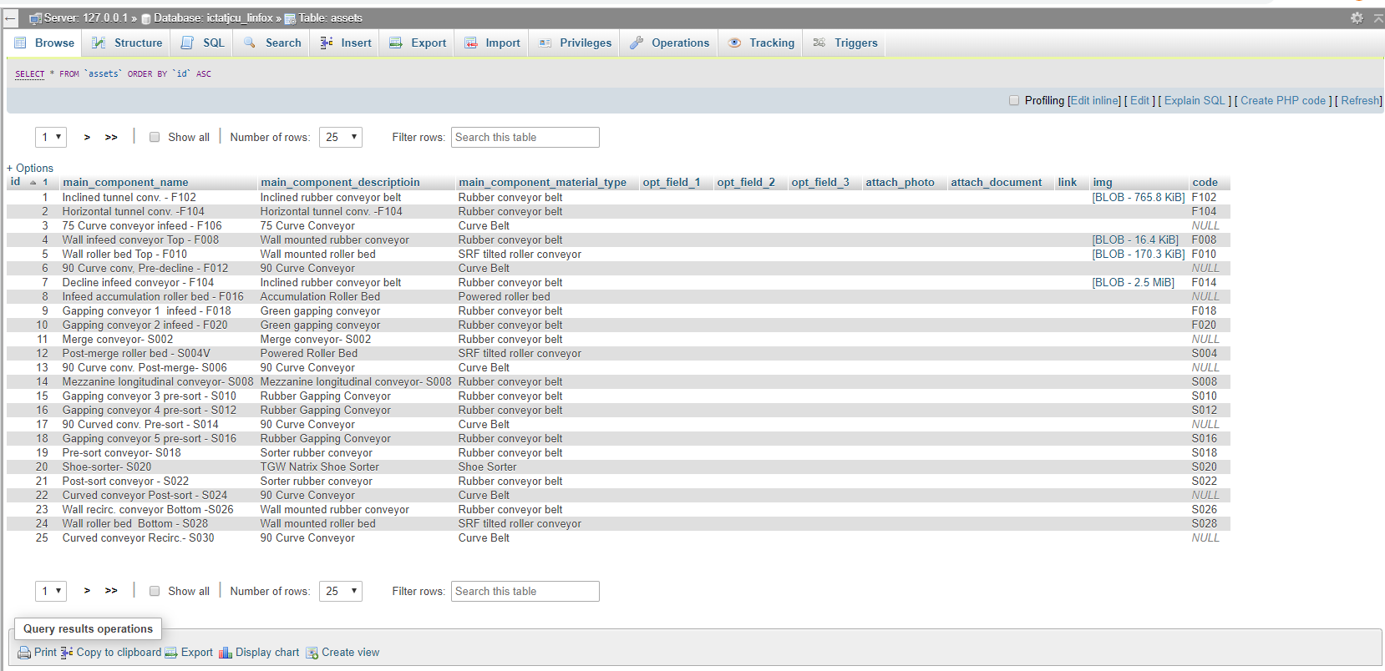

Ajax:

Ajax, a subset of JavaScript, was very useful when creating pop-up forms. This form is displayed as an asset by clicking in the mapped conveyor layout image. Used by the back end, clicking on Ajax enables communication with the server and retrieves data from the database.